APPENDIX E – RAPID ELECTRIC VEHICLE CHARGE POINT – UXBRIDGE ROAD, HATCH END

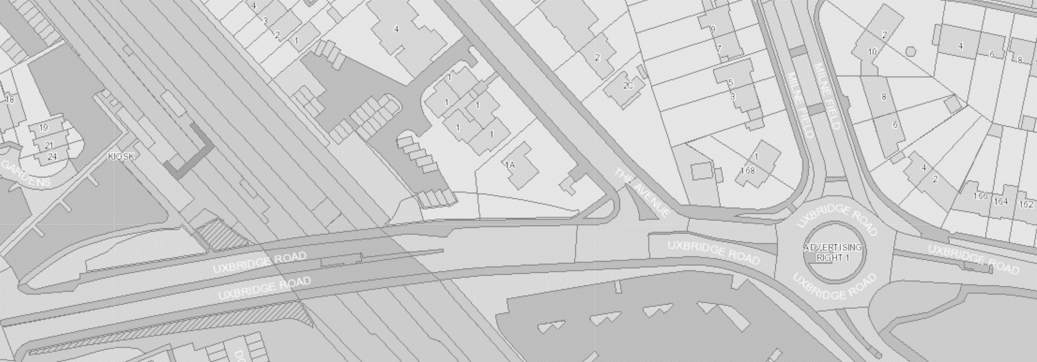
Milne Field
The Avenue
Uxbridge Road

